**EXPERIMENT NO. 05**

SIMULATION AND TESTING OF OPEN SHORTEST PATH FIRST (OSPF) ROUTING PROTOCOL USING CISCO PACKET TRACER.

**EXPERIMENT NO. 05**

**AIM: -** To simulate & test Open Shortest Path First (OSPF) routing protocol using Cisco Packet Tracer.

**OBJECTIVES:**

1. To simulate OSPF routing protocol, check the updated routing tables & check the connectivity among the devices.
2. To analyze OSPF routing metric calculation
3. To analyze OSPF routing tables before and after activation of alternate routing path.

**SOFTWARE:** Cisco Packet Tracer.

**SCENARIO:**

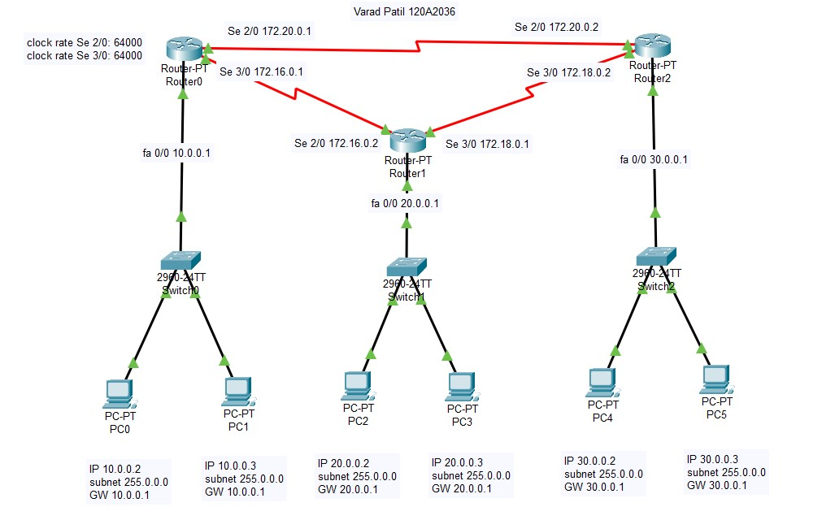

# CONFIGURATION OF FASTETHERNET0/0 INTERFACE OF Router0

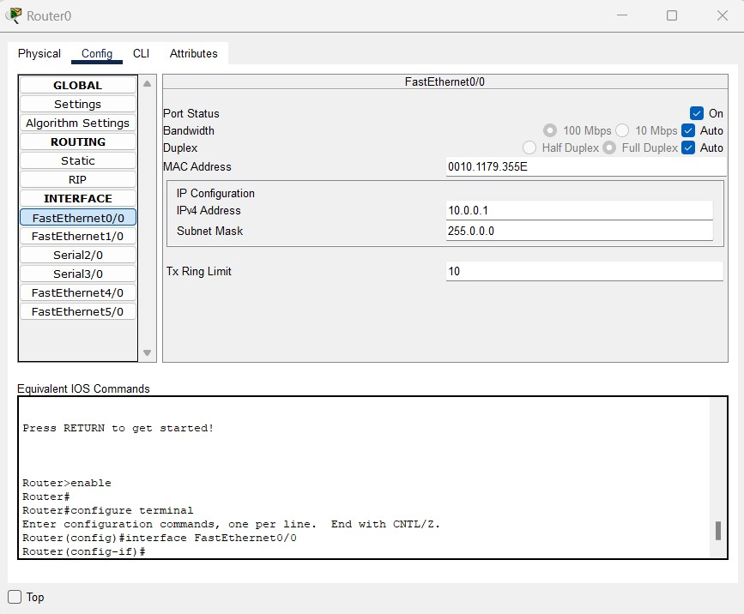

# CONFIGURATION OF SERIAL2/0 INTERFACE OF Router0

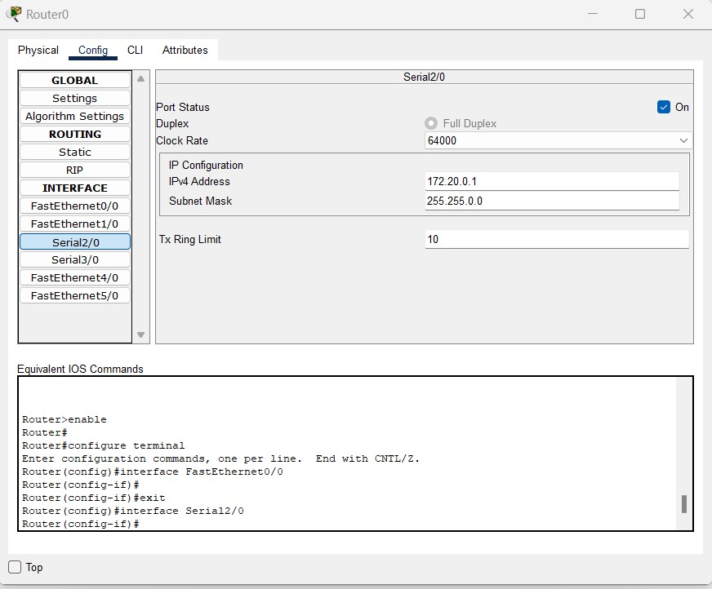

# CONFIGURATION OF OSPF ON Router0

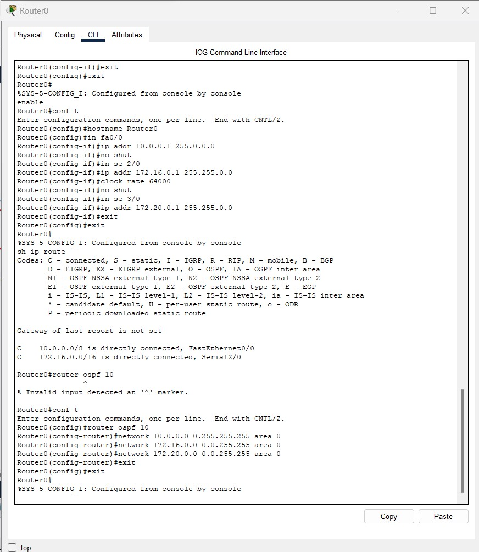

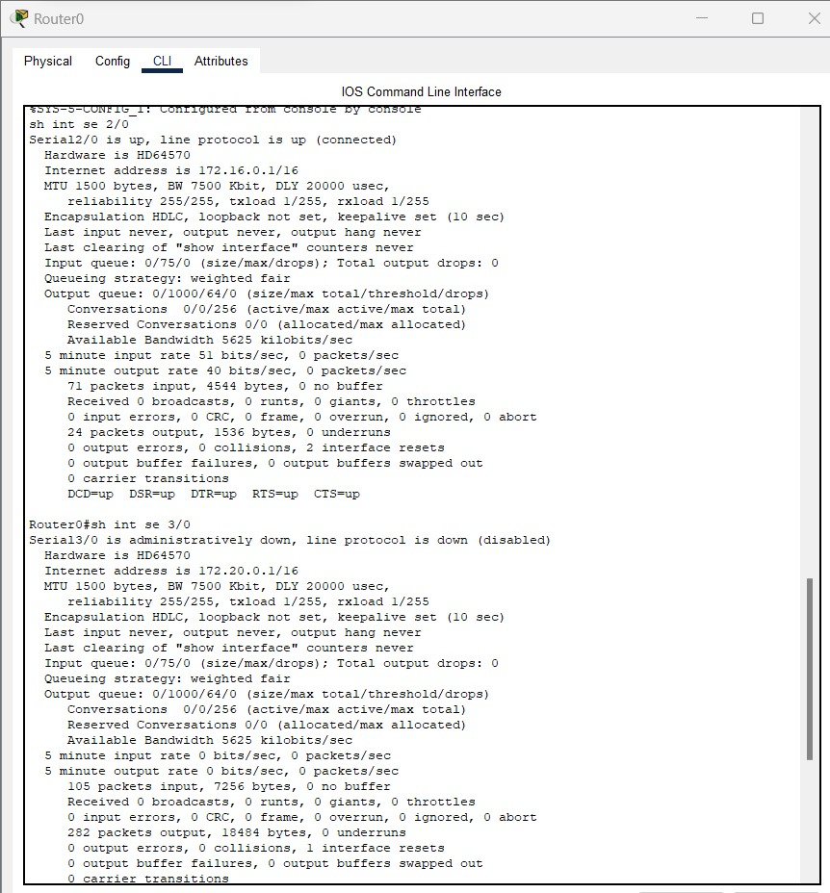

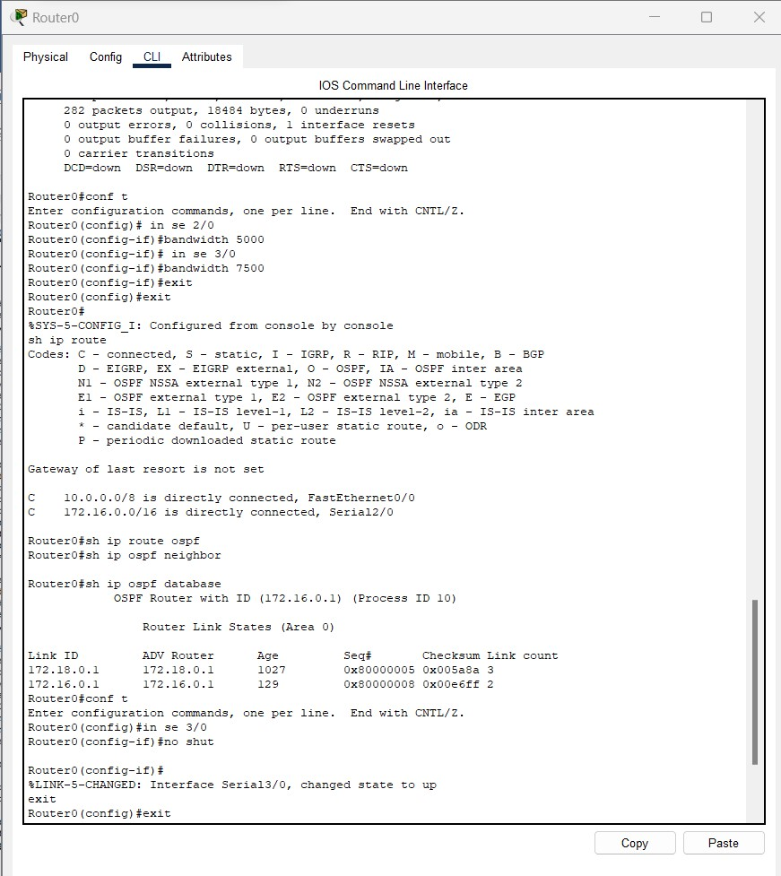

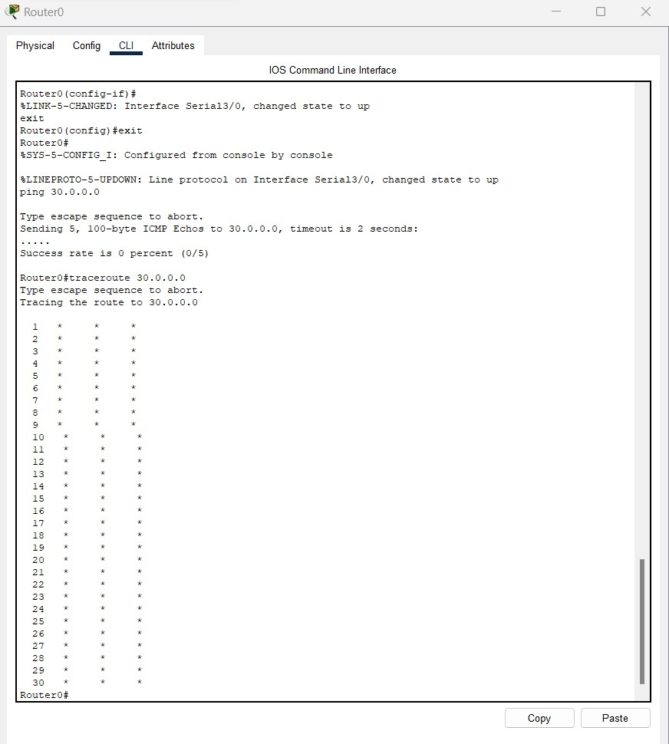

# BANDWIDTH INTERFACE OF SERIAL2/0 INTERFACE OF Router0

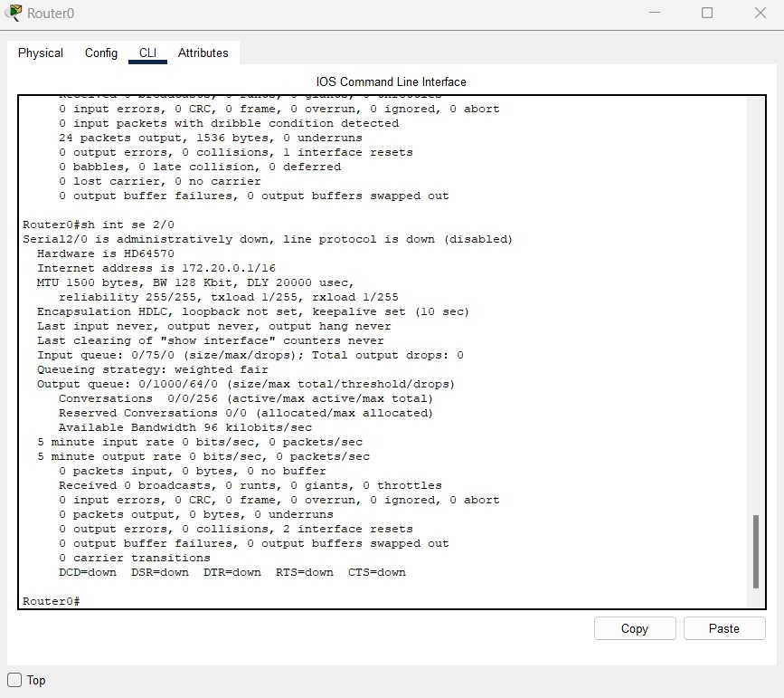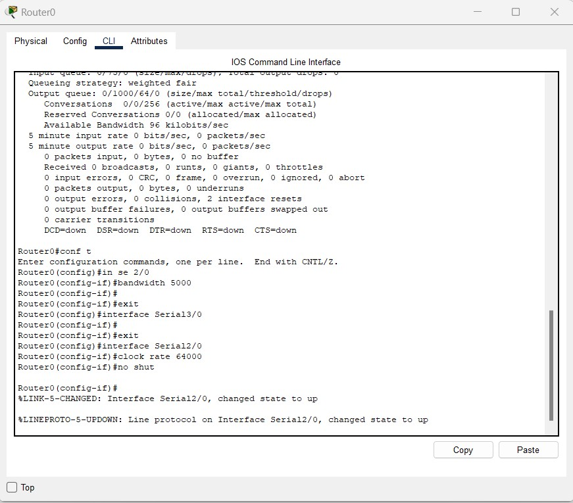

# BANDWIDTH INTERFACE OF SERIAL3/0 INTERFACE OF Router0

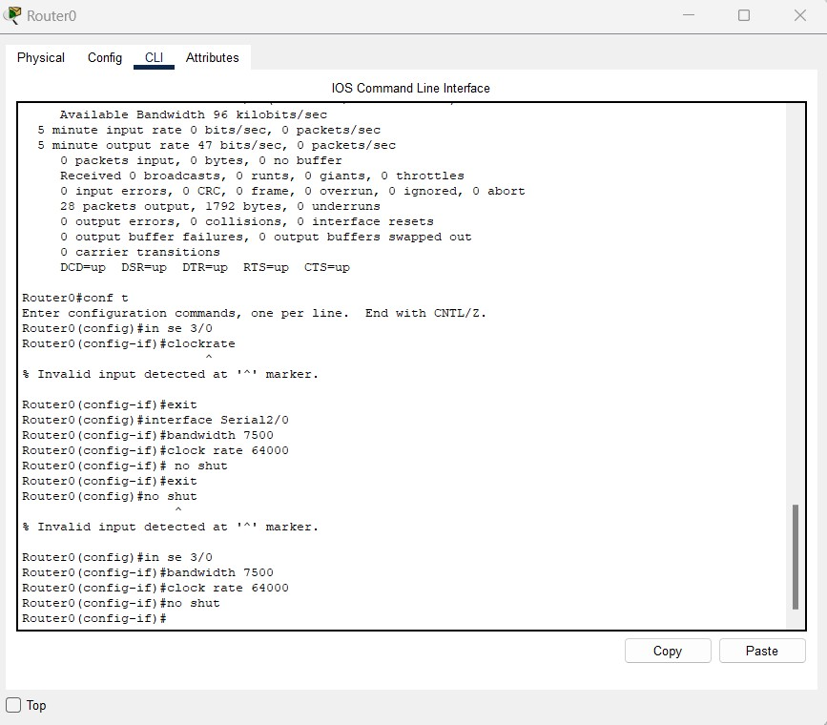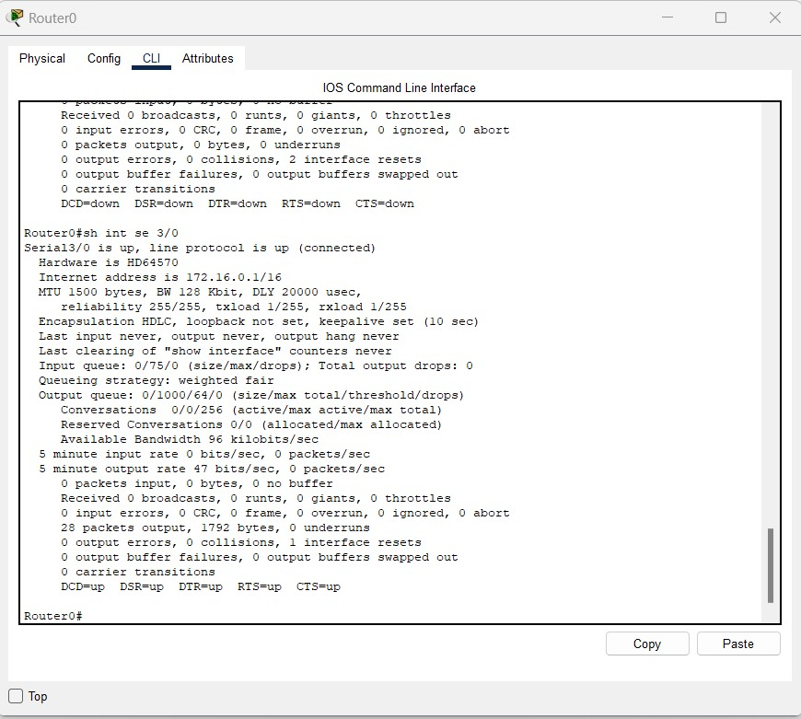

# UPDATING ROUTING TABLES Router0

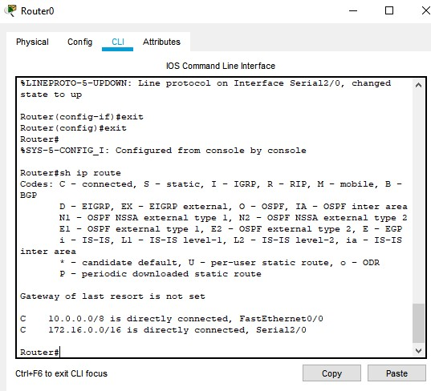

# OSPF DATABASE TABLES ON ROUTER 0

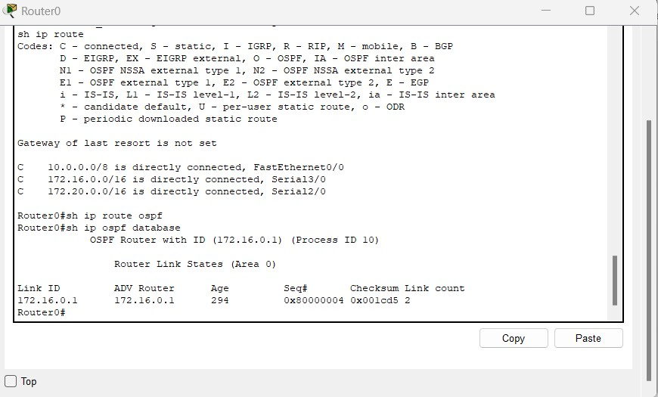

# OSPF NEIGHBOUR TABLES ON ROUTER 0

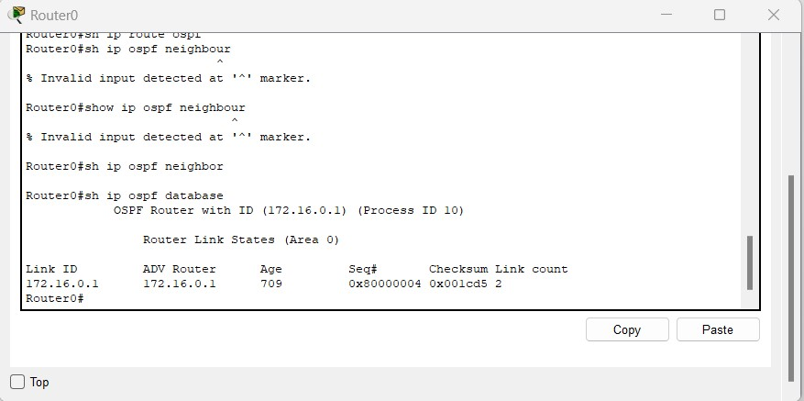

## CONFIGURATION OF FASTETHERNET0/0 INTERFACE OF Router1

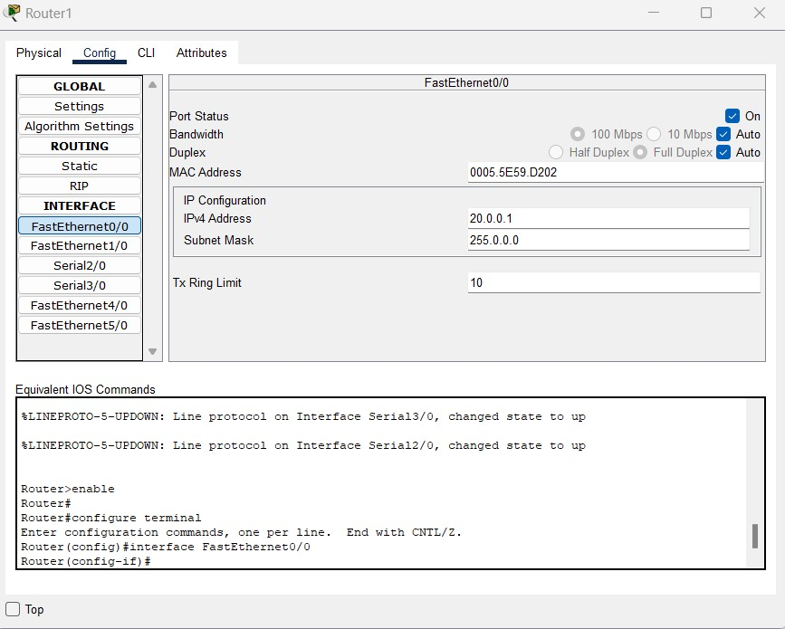

## CONFIGURATION OF SERIAL2/0 INTERFACE OF Router1

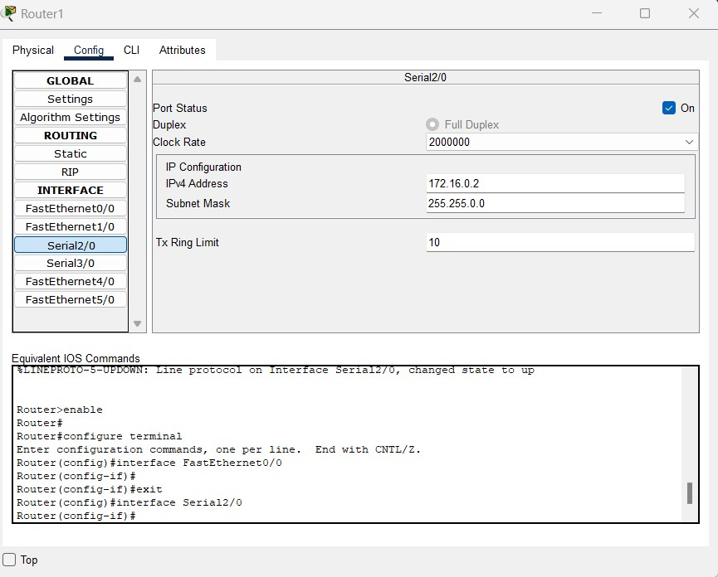

## CONFIGURATION OF SERIAL3/0 INTERFACE OF Router1

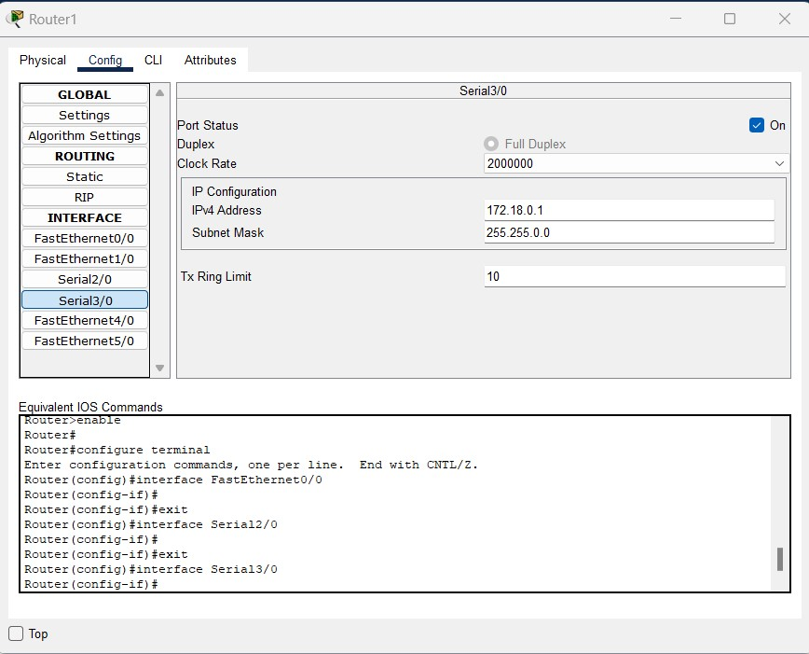

## UPDATING ROUTING TABLES Router1

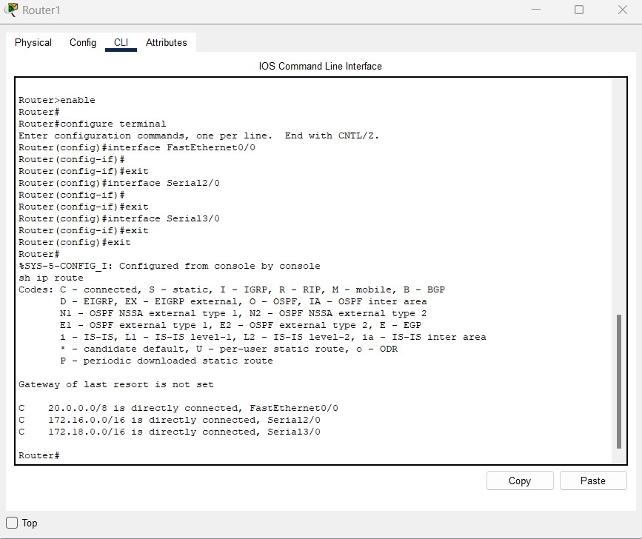

## OSPF CONFIGURATION on Router1

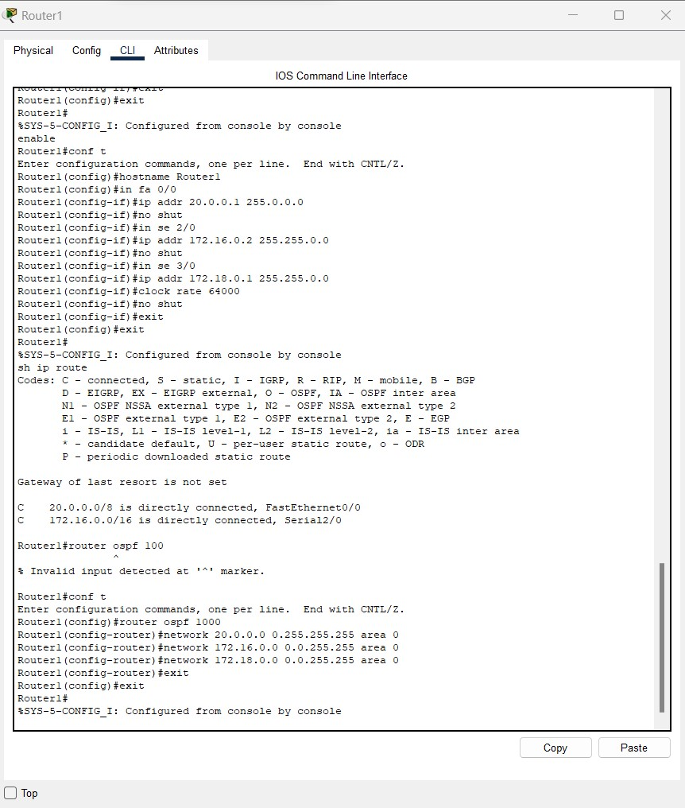

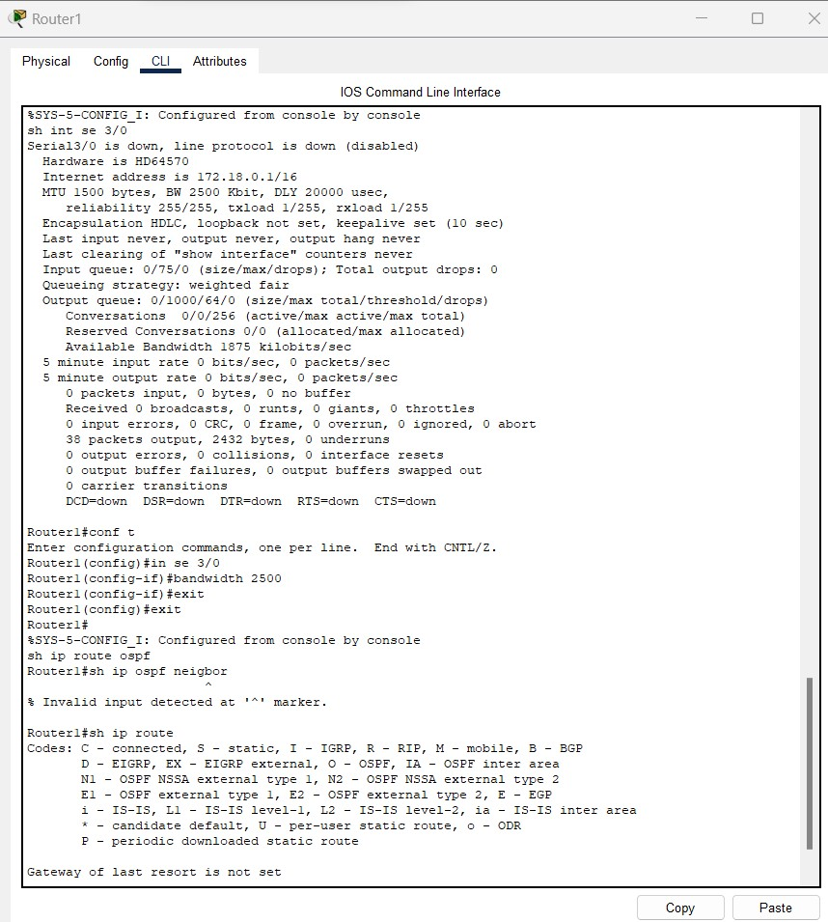

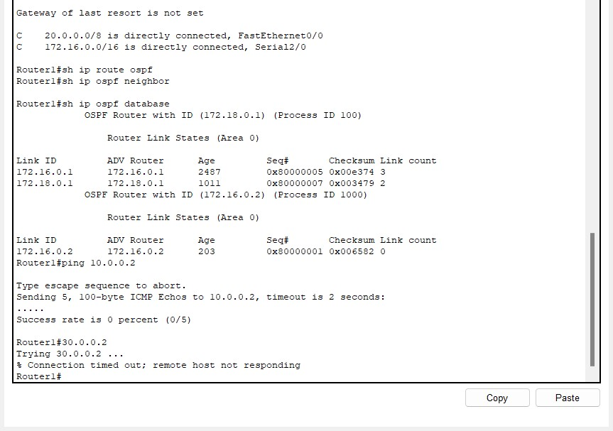

# BANDWIDTH INTERFACE OF SE 3/0 ON ROUTER 1

**OSPF DATABASE TABLES ON ROUTER 1**

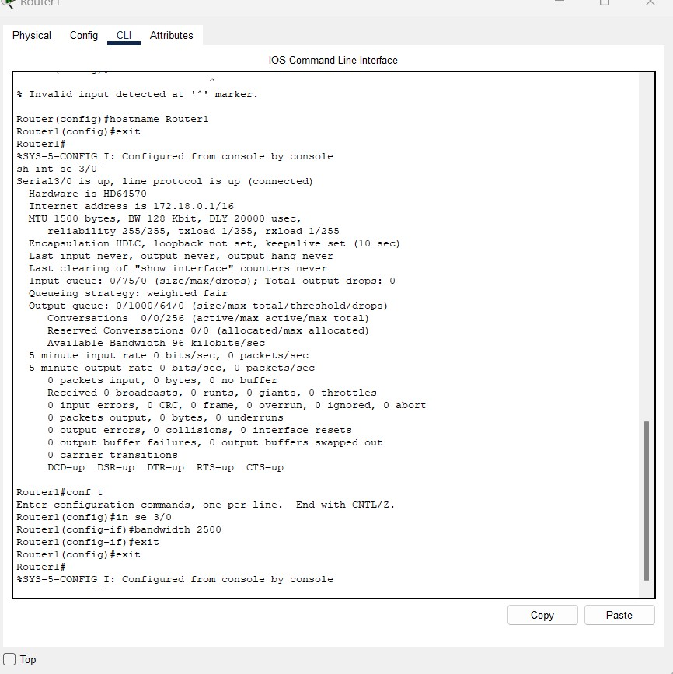

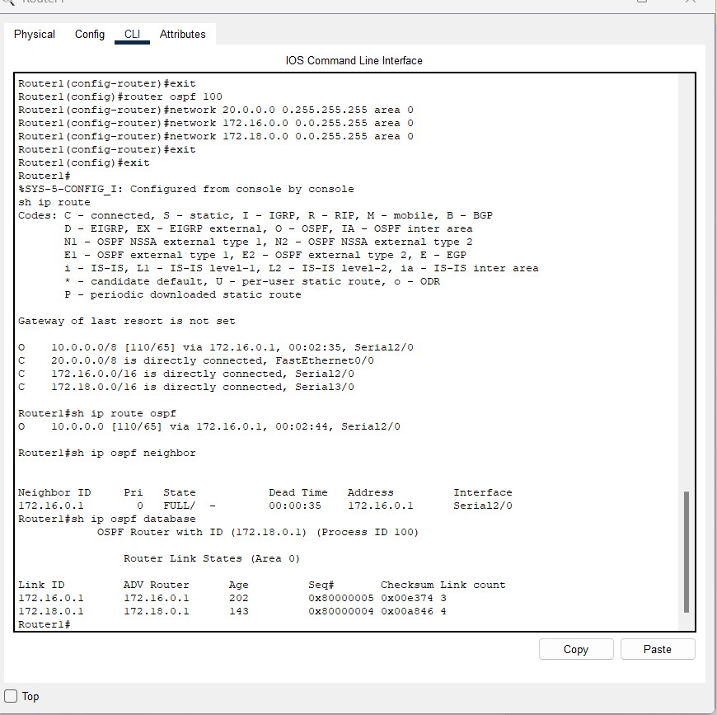

# OSPF NEIGHBOUR TABLES ON Router1



## PING RESPONSE: Router1

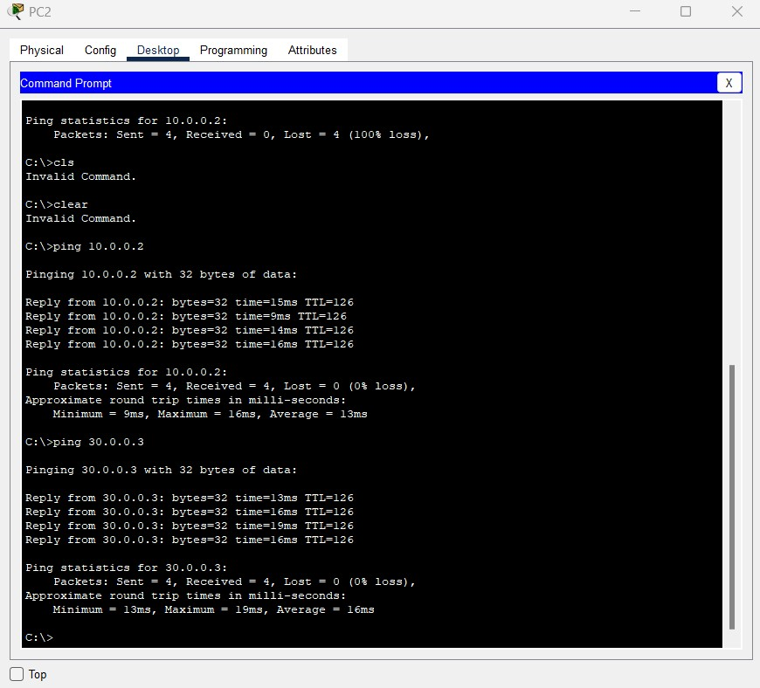

## CONFIGURATION OF FASTETHERNET0/0 INTERFACE OF Router2

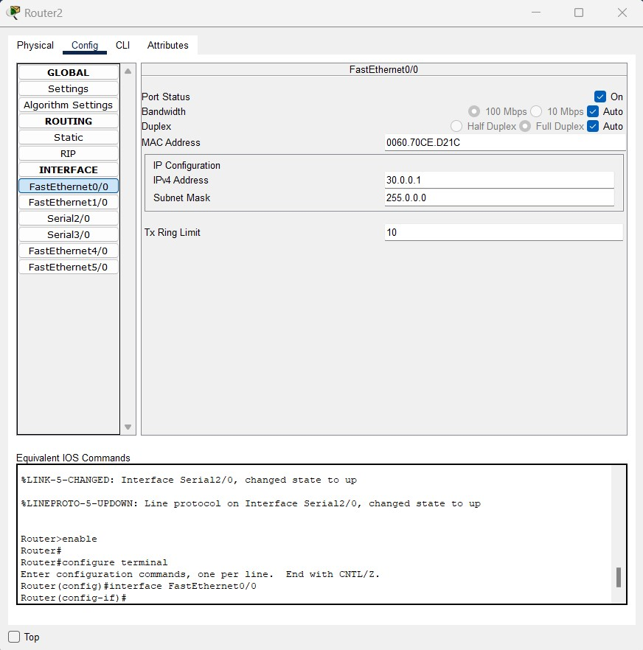

## CONFIGURATION OF SERIAL2/0 INTERFACE OF Router2

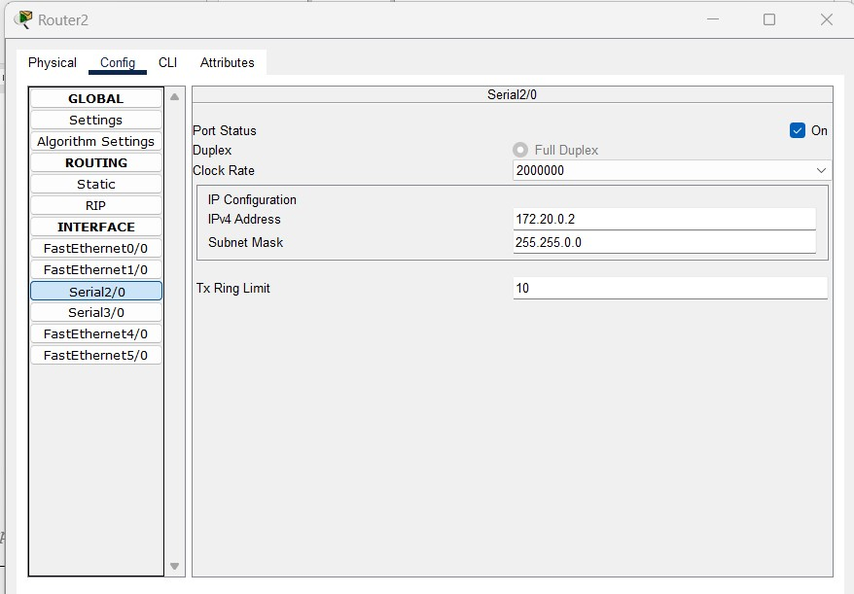

# OSPF CONFIGURATION ON ROUTER 2

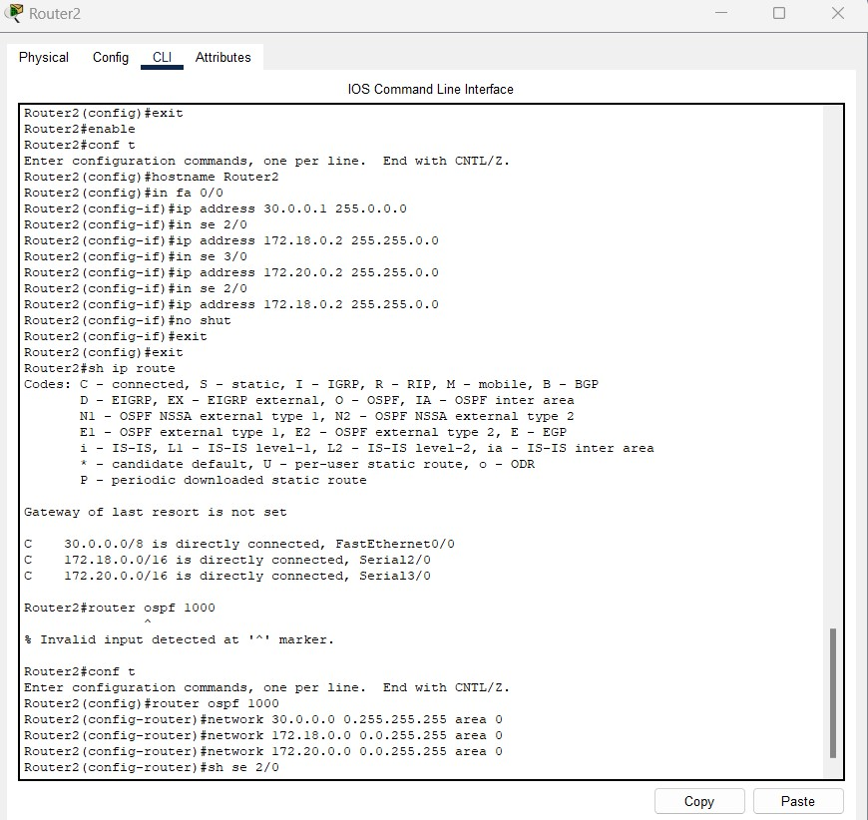

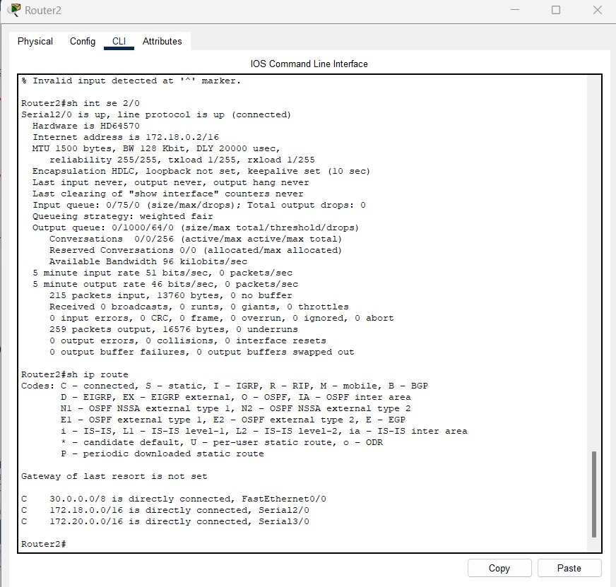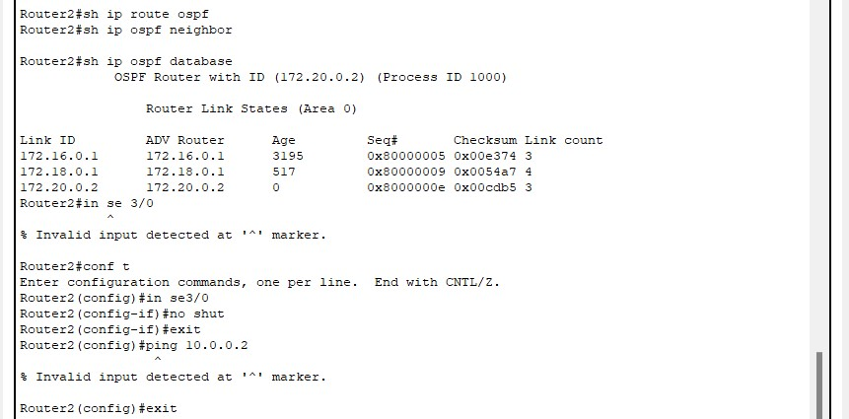

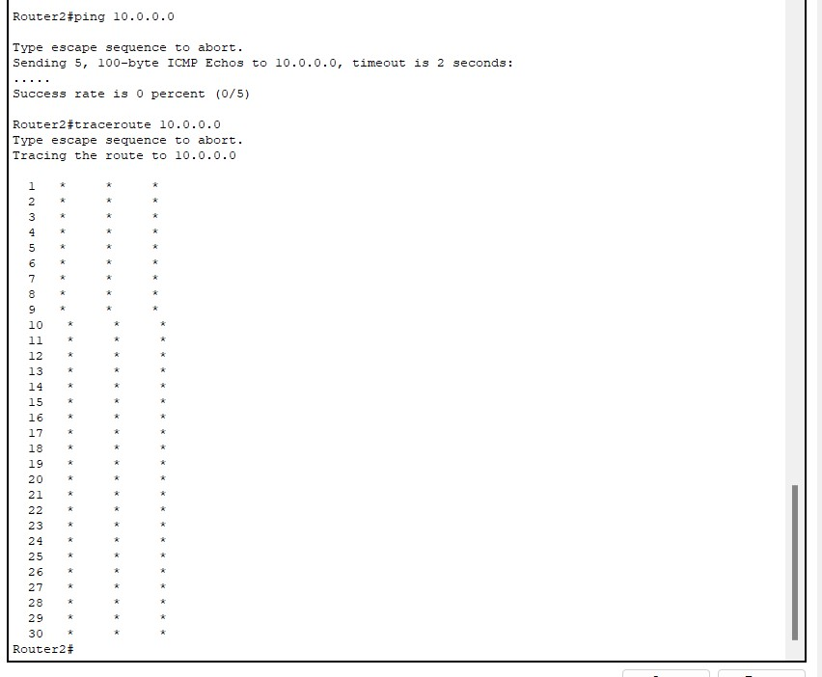

# BANDWIDTH INTERFACE SE 2/0 ON ROUTER 2

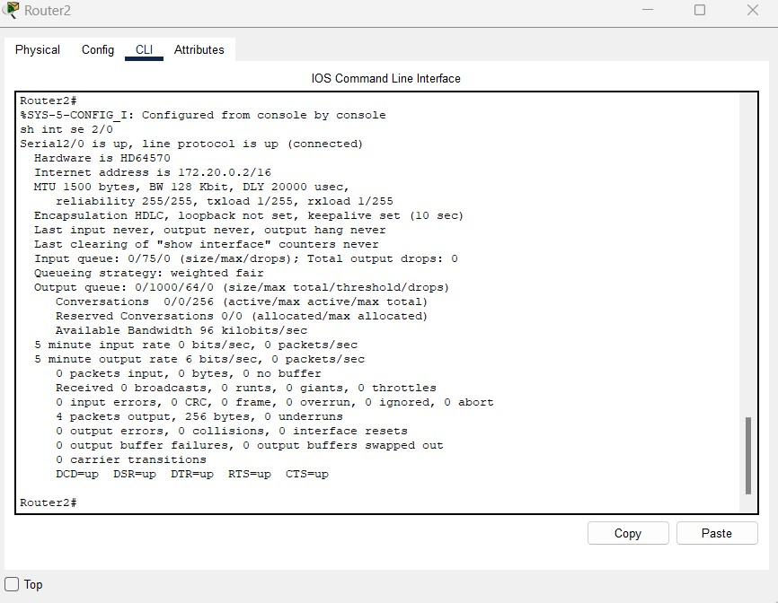

# UPDATED ROUTING TABLES ON ROUTER 2

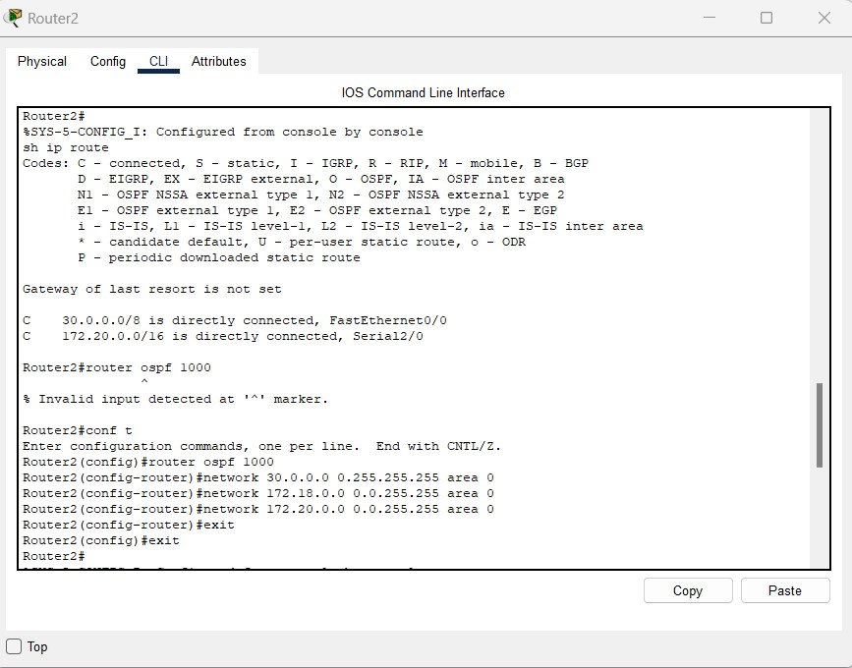

# OSPF DATABASE TABLES ON ROUTER 2

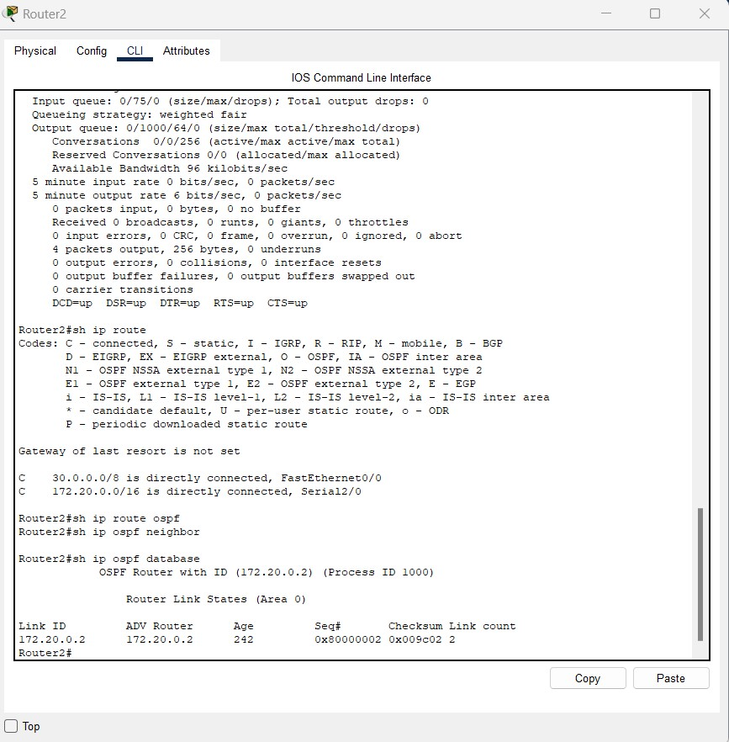

# OSPF NEIGHBOUR TABLES ON ROUTER 2



# PING RESPONSE ON ROUTER 2

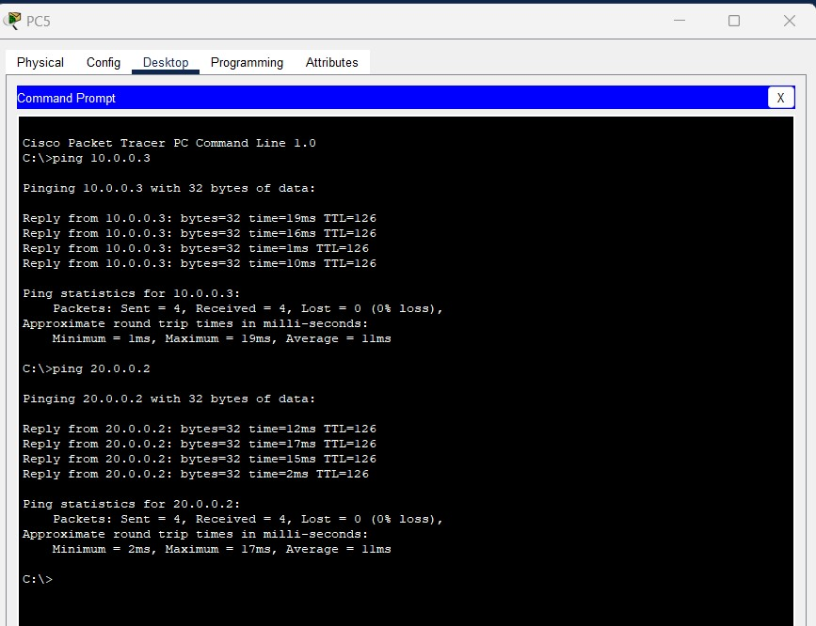

**CONCLUSION:**

In this experiment, we studied and performed simulation and testing of open shortest path first (ospf) routing protocol using cisco packet tracer.